Example 1
- Payer is “National Government Services” which is Medicare
- Subtract CO adjustments from charges. Do not calculate paid
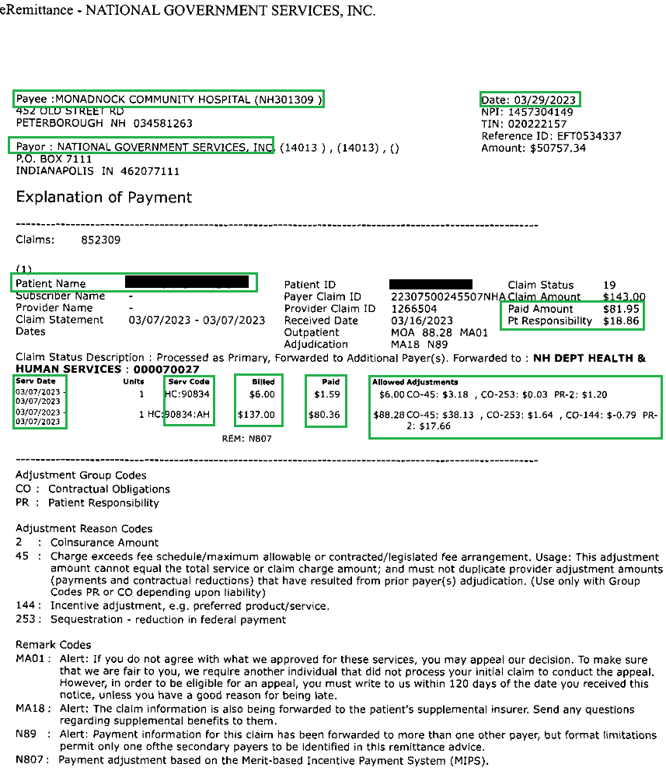

Example 2
- Insurance Carrier listed as “Medicare Part A and B”
- No formula required because all values are given, but formula using values provided is:
- $201.00 billed - $121.81 not allowed = $79.19 allowed
- CO-45 120.52 + CO-253 $1.29 = total not allowed $121.81
- Allowed $79.19 - $16.10 coinsurance = $63.09 paid

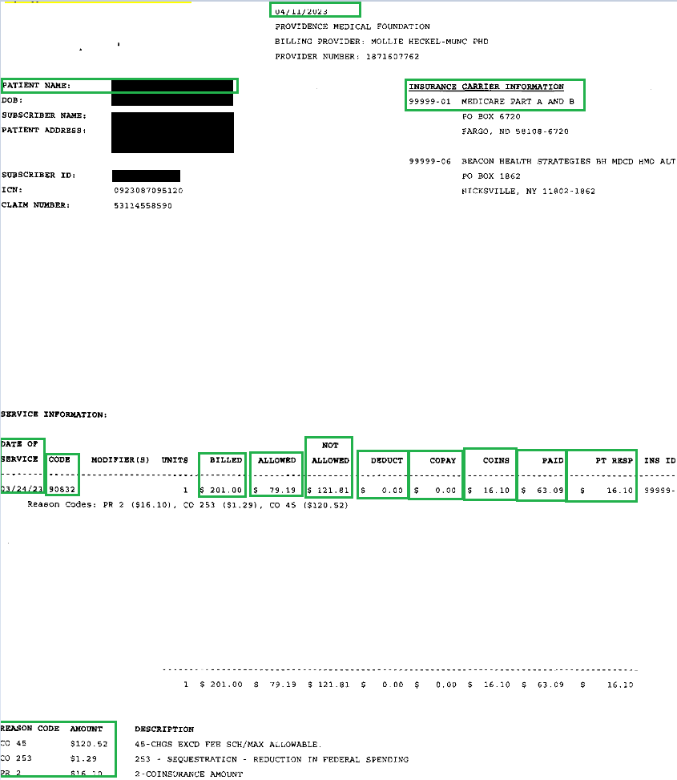

Example 3:
- Payer is “Anthem Blue Cross” no reference to gov/Medicare, so enter as Commercial.
- This EOB gives an itemized bill (first line), and a member total (second line). Be sure to enter the itemized lines (indicated by service code) if itemized.

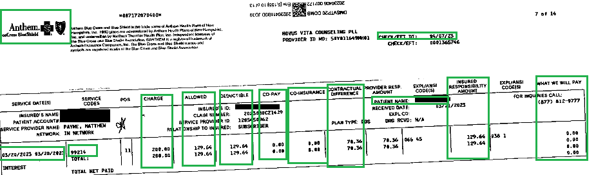
Example 4:
- Noridian JEA payer, known Medicare vendor, entered as Medicare OI
- Note multiple claim lines, differentiated by DOS.
- Black highlighted part of EOB is claim level payment, not needed to enter
- Blue highlighted is COB info for first DOS/line for 02/02
- Green highlights are the CARC codes:
- Note the CO-45, CO 253, and PR2 are on far right but their values are on far left.
- Enter COB info on all corresponding individual lines on FlexCare claim
